DBMS LAB ASSIGNMENT - 11
Cursors in PL/SQL
🧱 Table Setup
CREATE TABLE Student (
Rollno NUMBER PRIMARY KEY,
name VARCHAR2(50),
age NUMBER,
mark1 NUMBER,
mark2 NUMBER,
mark3 NUMBER,
total NUMBER
);
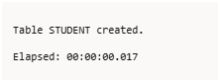
-- Sample data
INSERT INTO Student VALUES (1, 'Aman', 22, 25, 30, 35, 0);
INSERT INTO Student VALUES (2, 'Riya', 24, 30, 35, 40, 0);
INSERT INTO Student VALUES (3, 'Karan', 26, 40, 45, 35, 0);
INSERT INTO Student VALUES (4, 'Simran', 23, 38, 29, 28, 0);
INSERT INTO Student VALUES (5, 'Neha', 27, 45, 40, 35, 0);
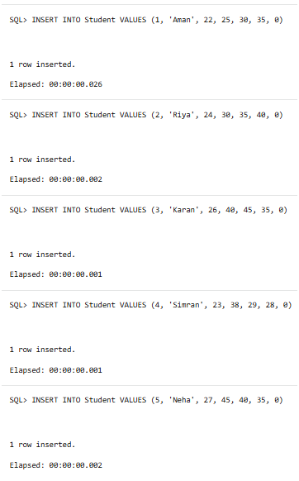
Q1. Cursor to move students (age < 25) to Student_minor
SOLUTION:- -- Create second table
CREATE TABLE Student_minor AS SELECT * FROM Student WHERE 1=2;

DECLARE
CURSOR c1 IS SELECT * FROM Student WHERE age < 25;
v_rec c1%ROWTYPE;
BEGIN
FOR v_rec IN c1 LOOP
INSERT INTO Student_minor VALUES v_rec;
DELETE FROM Student WHERE Rollno = v_rec.Rollno;
END LOOP;
DBMS_OUTPUT.PUT_LINE('Records moved successfully.');
END;
/

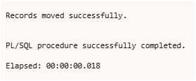
Q2. Cursor to calculate and update total marks
SOLUTION:- DECLARE
CURSOR c2 IS SELECT Rollno, mark1, mark2, mark3 FROM Student;
v_roll Student.Rollno%TYPE;
v_total NUMBER;
BEGIN
FOR rec IN c2 LOOP
v_total := rec.mark1 + rec.mark2 + rec.mark3;
UPDATE Student SET total = v_total WHERE Rollno = rec.Rollno;
END LOOP;
DBMS_OUTPUT.PUT_LINE('Total marks updated successfully.');
END;
/
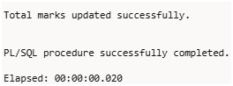
Q3. Cursor to display students with total > 90
SOLUTION:- DECLARE
CURSOR c2 IS SELECT Rollno, mark1, mark2, mark3 FROM Student;
v_roll Student.Rollno%TYPE;
v_total NUMBER;
BEGIN
FOR rec IN c2 LOOP
v_total := rec.mark1 + rec.mark2 + rec.mark3;
UPDATE Student SET total = v_total WHERE Rollno = rec.Rollno;
END LOOP;
DBMS_OUTPUT.PUT_LINE('Total marks updated successfully.');
END;
/
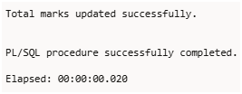
Q4. Cursor to find highest and lowest total marks
SOLUTION:- DECLARE
v_highest NUMBER;
v_lowest NUMBER;
BEGIN
SELECT MAX(total), MIN(total) INTO v_highest, v_lowest FROM Student;

DBMS_OUTPUT.PUT_LINE('Highest Total: ' || v_highest);
DBMS_OUTPUT.PUT_LINE('Lowest Total: ' || v_lowest);

DBMS_OUTPUT.PUT_LINE('---Highest Scorer(s)---');
FOR rec IN (SELECT * FROM Student WHERE total = v_highest) LOOP
DBMS_OUTPUT.PUT_LINE(rec.name || ' (' || rec.Rollno || ')');
END LOOP;

DBMS_OUTPUT.PUT_LINE('---Lowest Scorer(s)---');
FOR rec IN (SELECT * FROM Student WHERE total = v_lowest) LOOP
DBMS_OUTPUT.PUT_LINE(rec.name || ' (' || rec.Rollno || ')');
END LOOP;
END;
/
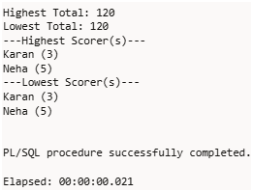
Q5. Cursor to find average marks of all students
SOLUTION:- DECLARE
CURSOR c5 IS SELECT total FROM Student;
v_sum NUMBER := 0;
v_count NUMBER := 0;
v_avg NUMBER;
BEGIN
FOR rec IN c5 LOOP
v_sum := v_sum + rec.total;
v_count := v_count + 1;
END LOOP;

v_avg := v_sum / v_count;
DBMS_OUTPUT.PUT_LINE('Average total marks = ' || v_avg);
END;
/
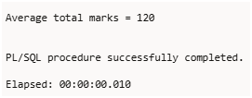
Q6. Parameterized cursor (display student by Rollno)
SOLUTION:- CREATE OR REPLACE PROCEDURE get_student_details(p_rollno IN NUMBER) IS
CURSOR c6 (rno NUMBER) IS SELECT * FROM Student WHERE Rollno = rno;
v_rec c6%ROWTYPE;
BEGIN
OPEN c6(p_rollno);
FETCH c6 INTO v_rec;
IF c6%FOUND THEN
DBMS_OUTPUT.PUT_LINE('Roll No: ' || v_rec.Rollno);
DBMS_OUTPUT.PUT_LINE('Name: ' || v_rec.name);
DBMS_OUTPUT.PUT_LINE('Age: ' || v_rec.age);
DBMS_OUTPUT.PUT_LINE('Total: ' || v_rec.total);
ELSE
DBMS_OUTPUT.PUT_LINE('No student found with Roll No ' || p_rollno);
END IF;
CLOSE c6;
END;
/
-- Execute
BEGIN
get_student_details(2);
END;
/
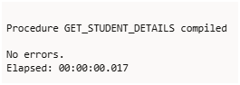
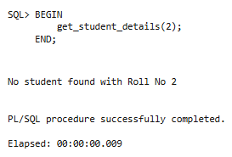
🧱 Table Setup (for all Q7–Q10)
CREATE TABLE EMP (
empno NUMBER PRIMARY KEY,
ename VARCHAR2(50),
job VARCHAR2(30),
sal NUMBER,
deptno NUMBER
);
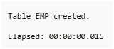
-- Sample data
INSERT INTO EMP VALUES (101, 'Amit', 'Manager', 60000, 10);
INSERT INTO EMP VALUES (102, 'Riya', 'Analyst', 50000, 10);
INSERT INTO EMP VALUES (103, 'Karan', 'Clerk', 30000, 20);
INSERT INTO EMP VALUES (104, 'Neha', 'Developer', 55000, 20);
INSERT INTO EMP VALUES (105, 'Simran', 'Tester', 40000, 10);
INSERT INTO EMP VALUES (106, 'Rohan', 'Manager', 70000, 30);
COMMIT;
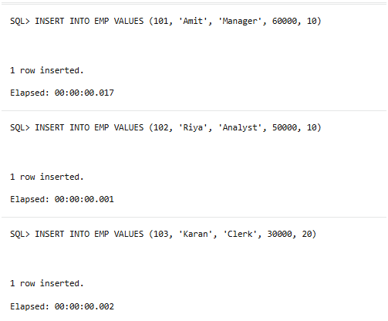
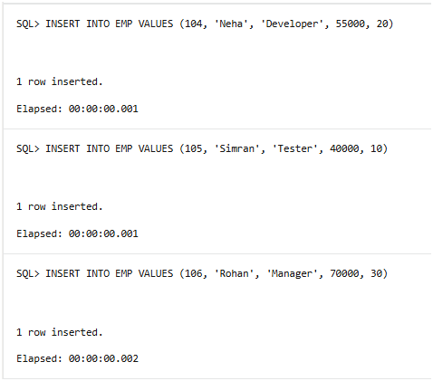
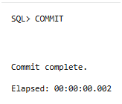
Q7. Demonstrate %TYPE and %ROWTYPE
SOLUTION:- DECLARE
v_empno EMP.empno%TYPE;
v_name EMP.ename%TYPE;
v_job EMP.job%TYPE;
v_row EMP%ROWTYPE;
BEGIN
DBMS_OUTPUT.PUT_LINE('---Using %TYPE---');
SELECT empno, ename, job INTO v_empno, v_name, v_job FROM EMP WHERE empno = 101;
DBMS_OUTPUT.PUT_LINE('EmpNo: ' || v_empno || ', Name: ' || v_name || ', Job: ' || v_job);

DBMS_OUTPUT.PUT_LINE(CHR(10) || '---Using %ROWTYPE---');
SELECT * INTO v_row FROM EMP WHERE empno = 102;
DBMS_OUTPUT.PUT_LINE('EmpNo: ' || v_row.empno || ', Name: ' || v_row.ename || ', Job: ' || v_row.job);
END;
/
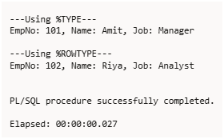
Q8. Stored Function using parameterized cursor (by deptno)
SOLUTION:- CREATE OR REPLACE FUNCTION get_emp_by_dept(p_deptno IN NUMBER)
RETURN VARCHAR2
IS
CURSOR c_emp (dno NUMBER) IS
SELECT empno, ename, job FROM EMP WHERE deptno = dno;

v_emp c_emp%ROWTYPE;
v_output VARCHAR2(4000) := '';
BEGIN
OPEN c_emp(p_deptno);
LOOP
FETCH c_emp INTO v_emp;
EXIT WHEN c_emp%NOTFOUND;
v_output := v_output || 'EmpNo: ' || v_emp.empno ||
', Name: ' || v_emp.ename ||
', Job: ' || v_emp.job || CHR(10);
END LOOP;
CLOSE c_emp;

RETURN v_output;
END;
/
-- Execute
DECLARE
v_result VARCHAR2(4000);
BEGIN
v_result := get_emp_by_dept(10);
DBMS_OUTPUT.PUT_LINE(v_result);
END;
/
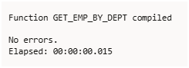
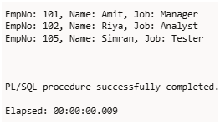
Q9. Local Function to display top ‘n’ highest-paid employees
SOLUTION:- DECLARE
FUNCTION top_n_employees(p_n NUMBER) RETURN VARCHAR2 IS
CURSOR c_emp (n NUMBER) IS
SELECT empno, ename, sal FROM (
SELECT empno, ename, sal FROM EMP ORDER BY sal DESC
) WHERE ROWNUM <= n;

v_rec c_emp%ROWTYPE;
v_output VARCHAR2(4000) := '';
BEGIN
OPEN c_emp(p_n);
LOOP
FETCH c_emp INTO v_rec;
EXIT WHEN c_emp%NOTFOUND;
v_output := v_output || 'EmpNo: ' || v_rec.empno ||
', Name: ' || v_rec.ename ||
', Salary: ' || v_rec.sal || CHR(10);
END LOOP;
CLOSE c_emp;
RETURN v_output;
END;
BEGIN
DBMS_OUTPUT.PUT_LINE(top_n_employees(3));
END;
/
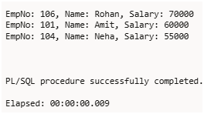
Q10. Local Procedure to calculate total salary of first ‘n’ records
SOLUTION:- DECLARE
PROCEDURE total_salary(p_n NUMBER) IS
CURSOR c_emp (n NUMBER) IS
SELECT sal FROM (
SELECT sal FROM EMP ORDER BY empno
) WHERE ROWNUM <= n;

v_sal EMP.sal%TYPE;
v_total NUMBER := 0;
BEGIN
OPEN c_emp(p_n);
LOOP
FETCH c_emp INTO v_sal;
EXIT WHEN c_emp%NOTFOUND;
v_total := v_total + v_sal;
END LOOP;
CLOSE c_emp;
DBMS_OUTPUT.PUT_LINE('Total salary of first ' || p_n || ' employees = ' || v_total);
END;
BEGIN
total_salary(4);
END;
/
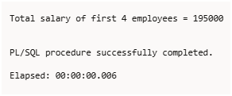

Exception Handling
-- Using the same EMP table as before
SELECT * FROM EMP;
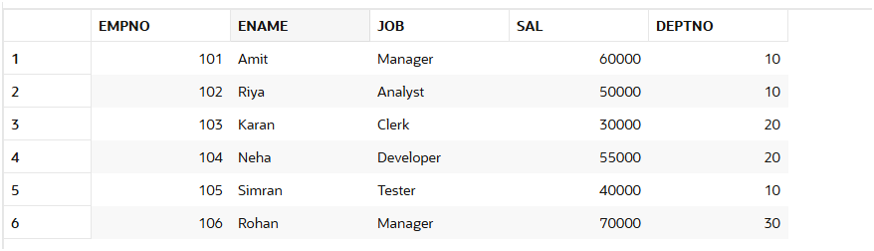
Q11. Demonstrate Predefined Exceptions
Exceptions Covered:
- TOO_MANY_ROWS
- NO_DATA_FOUND
- WHEN OTHERS
DECLARE
v_name EMP.ename%TYPE;
v_sal EMP.sal%TYPE;
BEGIN
DBMS_OUTPUT.PUT_LINE('--- Demonstrating Predefined Exceptions ---');

-- TOO_MANY_ROWS (More than one employee with job 'Manager')
BEGIN
SELECT ename, sal INTO v_name, v_sal FROM EMP WHERE job = 'Manager';
DBMS_OUTPUT.PUT_LINE('Employee: ' || v_name || ', Salary: ' || v_sal);
EXCEPTION
WHEN TOO_MANY_ROWS THEN
DBMS_OUTPUT.PUT_LINE('Error: TOO_MANY_ROWS - Multiple Managers found.');
END;

-- NO_DATA_FOUND (No employee with job 'President')
BEGIN
SELECT ename, sal INTO v_name, v_sal FROM EMP WHERE job = 'President';
DBMS_OUTPUT.PUT_LINE('Employee: ' || v_name || ', Salary: ' || v_sal);
EXCEPTION
WHEN NO_DATA_FOUND THEN
DBMS_OUTPUT.PUT_LINE('Error: NO_DATA_FOUND - No employee with job President.');
END;

-- WHEN OTHERS (any other unexpected exception)
BEGIN
DBMS_OUTPUT.PUT_LINE('--- Triggering WHEN OTHERS ---');
-- Intentionally dividing by zero to raise a generic exception
v_sal := 1000 / 0;
EXCEPTION
WHEN OTHERS THEN
DBMS_OUTPUT.PUT_LINE('Error: WHEN OTHERS - ' || SQLERRM);
END;
END;
/
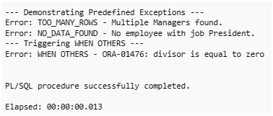
Q12. Demonstrate User-Defined Exception
SOLUTION:-
DECLARE
v_empno EMP.empno%TYPE := 999; -- Employee ID not in table
v_sal EMP.sal%TYPE;
e_invalid_empno EXCEPTION; -- user-defined exception
BEGIN
DBMS_OUTPUT.PUT_LINE('--- Demonstrating User-Defined Exception ---');

SELECT sal INTO v_sal FROM EMP WHERE empno = v_empno;

IF v_sal IS NULL THEN
RAISE e_invalid_empno;
END IF;

DBMS_OUTPUT.PUT_LINE('Salary of Employee ' || v_empno || ' = ' || v_sal);

EXCEPTION
WHEN NO_DATA_FOUND THEN
DBMS_OUTPUT.PUT_LINE('No employee found with empno ' || v_empno);
WHEN e_invalid_empno THEN
DBMS_OUTPUT.PUT_LINE('Invalid Employee Number entered.');
WHEN OTHERS THEN
DBMS_OUTPUT.PUT_LINE('Unexpected error: ' || SQLERRM);
END;
/
